WE NEED YOUR HELP

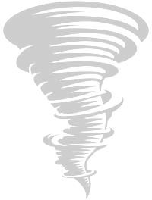

Small-group discussions inviting your ideas about how to improve information-sharing

during weather emergencies

# LOCATION

Montgomery County  
E911 Communications Center

130 South 1st Street

Clarksville TN 37040

# DATE & TIME

Saturday, June 28, 2025  
9am – 12pm (ASL)

12pm – 1:30pm (Lunch)

1:30pm – 4:30pm (CART)

# DURATION

* 2 separate sessions
* Approx. 4 hours

# ELIGIBILITY

* 18 years of age or older
* Deaf or Hard of Hearing
* Communicate in ASL or English

# FOR MORE INFORMATION Contact: EARS, Inc. (Emergency Awareness and Readiness Services for the Deaf & Hard of Hearing) [earsofmiddletn@gmail.com](mailto:earsofmiddletn@gmail.com)

# INTERESTED?

Complete a brief application using this link: https://www.surveymonkey.com/r/FWJD3VF

Includes short breaks & free lunch

**DEADLINE for application is June 22, 2025.**

  

**Project Manager:** Dr. Chongming Wang