CHATTANOOGA AREA EMPLOYMENT CONSORTIUM
cordially invites you to attend the 14th Annual
DISABILITY AWARDS LUNCHEON

Honoring the 2014 Award Recipients for
Employers and Employees from Hamilton County
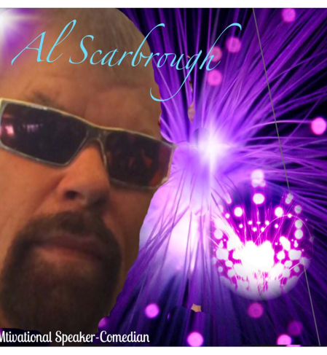

Who: Luncheon Speaker Al Scarbrough
When: Tuesday, October 14, 2014
Where: The Convention and Trade Center
Carter St, Chattanooga, TN
Time: 11:30 a.m. to 1:30 p.m.

Al is a motivational speaker, professional comedian, and an assistive technology trainer for the National Deaf-Blind Equipment Distribution Program. In 2001 Al became legally blind from optic nerve strokes. After that he had a succession of depression, a suicide attempt, weight gain, diabetes, hearing loss and chronic pain syndrome. Through sheer determination, hard work, a CAN DO attitude and a good sense of humor he was able to turn his challenges into successes. In 2005 Al worked for United Way presenting 91 times and raising more money than any other speaker in the Southeast TN area. Please join us this year as we celebrate successes with people of all abilities.
Sponsors: 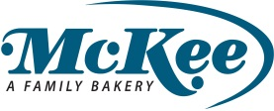
Registration Deadline
September 30, 2014
REGISTRATION FORM
Participant Information
Individual ($40 per Individual)
Corporate Table: ($300 per table with a maximum of 8 Representatives)
Attendee:
Attendee:
Attendee:
Attendee:
Unused places will be reserved for special guests, award recipients and their family members.
Company / Organization:
Address: City, State, ZIP Code:
Accommodations Needed & Type: Interpreter Needed? Yes No Other (Please specify):
Contact Name & Telephone:
REGISTRATION Send this Registration Form to: David Fields, Corporate Connections
MAIL: Eastgate Mall, 5600 Brainerd Road, Suite 602-B, Chattanooga, TN 37411
FAX: (423) 634-1976 EMAIL: dfields@utk.edu
PAYMENT Invoice will be sent to you upon receipt of this Registration Form.
QUESTIONS For more information contact David Fields at (423) 634-6728

