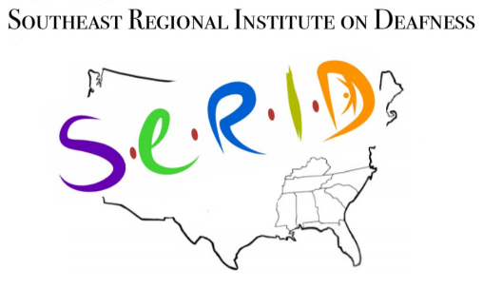
SERID Seminars 2020

In lieu of postponing the 2020 SERID Conference, SERID, INC. gladly presents:
SERID Seminars

SERID Seminars will provide a virtual opportunity for professional development with unique topics that impact the Deaf, DeafBlind and Hard of Hearing communities.

All Seminars will be from 2:00 PM – 4:00 PM Eastern Time.

SAVE THE DATES for our first SERID Seminars!

Thursday, October 29, 2020
Friday, November 6, 2020
Friday, November 13, 2020
Friday, November 20, 2020

Each Seminar will offer FREE CRCC and RID CEUs, pending approval.

THANK YOU!

