SayWhatClub CONVENTION
AUGUST 10th -13th Drury Plaza Downtown Nashville
300 Korean Veterans Blvd., Nashville, TN 37201
EARLY BIRD REGISTRATION DEADLINE APRIL 30, 2022

Join us at the 2022 SWC Convention. Register for the Convention or just a single day! Complete with Music City tours, embracing music after hearing loss and workshops including Mental Wellness, Empowerment - Living Beyond Hearing Loss, Advocating for Big Change, Cochlear Implant and Hearing Aid Updates and Research, Introduction to Tai Chi and the special Saturday evening Banquet with Keynote Speaker, Meaghan Thomas, from WKRN News Channel 2 in Nashville. Learn about her own hearing loss and giving back. Bring your hearing family members and friends and join in the fun.

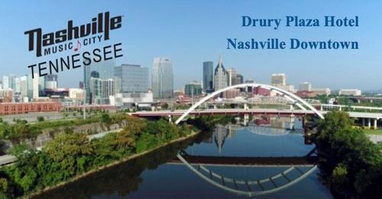

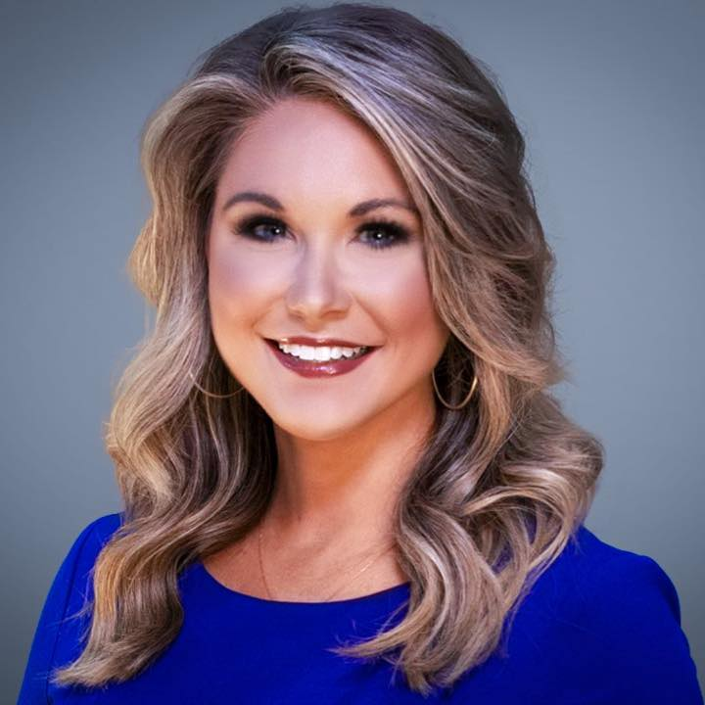

SayWhatClubbers have been gathering at the SWC Conventions each year since 1996 to connect with and/or meet those who belong to our online support groups/communities in person. Family members and friends are an important part of this event and are always welcome!
Join our free online support groups and come celebrate being empowered by spending time with others who “get” you this year at the SWC Convention at the Drury Plaza Downtown Nashville. The hotel includes free breakfast and three evening happy hour drinks and appetizers. It is walking distance to a variety of events we will participate in together from the Country Music Hall of Fame and Ryman Auditorium to the TN Museum and Farmers Market/Bicentennial Park. There is not right or wrong way to live with hearing loss and deafness. But there are options!
Sign up TODAY!
Early Bird registration ends April 30th, 2022
Sign up for the Convention or just come for a single day: Click here

