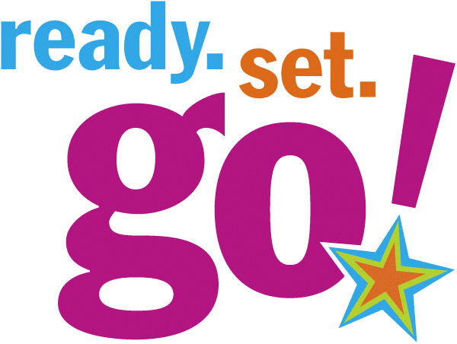
NAME OF THE PROGRAM: “Ready Set Go!” Pilot
TARGETED POPULATION: Deaf, Hard of Hearing, and Deaf-Blind high school students
TARGET NUMBER TO SERVE: Maximum of 16
TARGETED TIMEFRAME: Six-five hour sessions (Monday, Wednesday, Friday) over the span of two weeks. Daily sessions will begin at 9:00 am and end at 2:30 pm.
MAJOR EMPHASIS: Provide students the tools and experiences needed to obtain successful and satisfying employment. This program will focus on preparing the student with hands-on learning, discussion, informational handouts, and information to achieve the realistic careers they desire. Topics covered would include:
- Workplace Readiness (Attitude, Appearance, Action)
- Job Exploration
- Guest speakers who are deaf, hard of hearing, and deaf-blind present information about their jobs and education
- Accommodations for the Workplace (Disability Rights of Tennessee)
- Technology and Services
- Shadowing assignments
- Finances
- How to find a job (Newspaper, Internet, People you know, Cold Calls)
- How to create a professional resume

For additional information:
Janet L. Morris, Clinical Services Administrator
Phone: (615) 223-2716 Email: janet.l.morris@tn.gov
Tennessee Rehabilitation Center
460 9th Avenue, Smyrna, TN 37167

