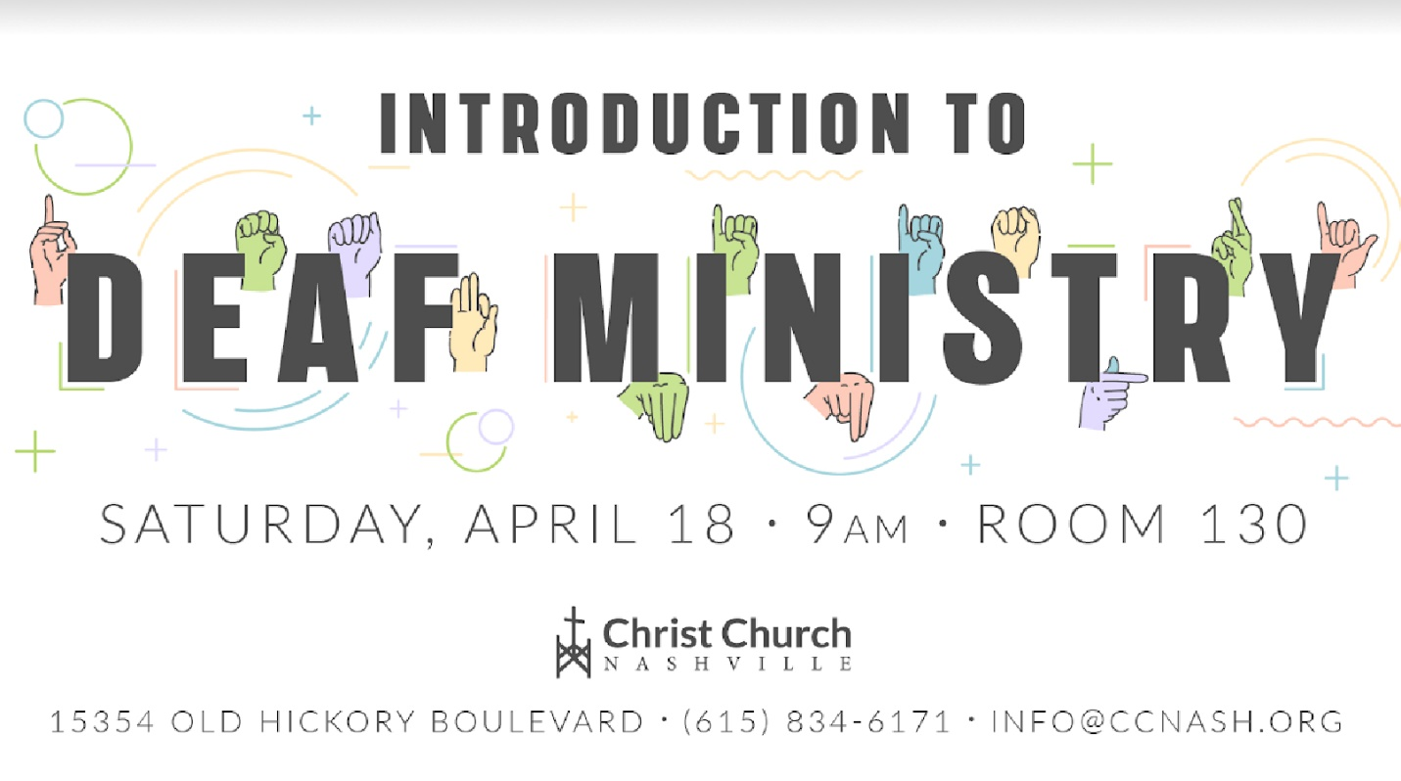

This is a **FREE** workshop that is offered to interpreters of ***any*** skill level to learn more about how to:

* + - * + Establish a Deaf Ministry
        + Interpret religious vocabulary
        + Keep your interpreting simple
        + Improve your musicality

The workshop begins at 9:00 and ends at 3:00. By the way, lunch will be provided **FREE** of charge for those who register prior to April 11th! Please call or e-mail Christ Church to register for this workshop!