C:\Users\Tracy\AppData\Local\Microsoft\Windows\Temporary Internet Files\Content.IE5\MM9M7VL7\MC900078756[1].wmf  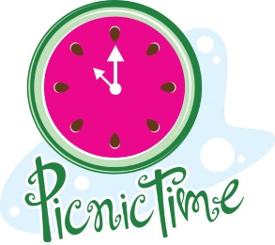

Family Fun Picnic

Saturday, July 26, 2014

11:00 – 2:00 p.m.

Fannie Mae Dee’s Park Pavilion

2400 Blakemore Ave, Nashville, TN 37212

C:\Users\Tracy\AppData\Local\Microsoft\Windows\Temporary Internet Files\Content.IE5\MM9M7VL7\MC900002168[1].wmf C:\Users\Tracy\AppData\Local\Microsoft\Windows\Temporary Internet Files\Content.IE5\MM9M7VL7\MC900064979[1].wmf

Games and crafts for the children.

Make new friends or meet friends and family.

Learn about what TN Hands & Voices is doing.

Come enjoy hot dogs, chips, and beverages.

Please bring side dishes or dessert to share with others.

Dietary limitations? Please bring your own food.

Inclement weather? Check on:

<http://www.tnhandsandvoices.org>

<http://www.facebook.com/tnhandsandvoices>

Call or text: 615.429.0368