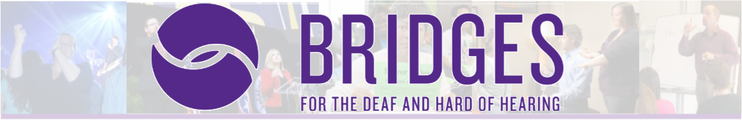
Best Practices: When Working with a Deaf Interpreter
Presenter: Kimwanis Jordan and J. Eric Workman October 8, 2020 | 5:00pm-7:00pm
Bridges for the Deaf and Hard of Hearing Zoom Platform

Cost: Free | Refreshments will be provided

Register: Contact Amy Lankheit at amy@bridgesfordeafandhh.org by October 5, 2020 to register.

Participants will learn by presenter’s information as well as hands-on activities in a safe and encouraging environment about how to team professional with a deaf Interpreter. The proper roles of each member of the Deaf-Hearing Team will be addressed, as well as how to problem solve as a team.
About the Presenters
Kimwanis Jordan is a native language ASL user who has served as a Deaf Interpreting for middle Tennessee and the surrounding area since 2016. She has served the community in a variety of setting including medical, mental health, legal, performing arts, employment, among others. She has had extensive education in mental health interpreting from the Alabama Department of Mental Health’s week-long intensive training. She also recently participated in Project CLIMB, an intensive training promoting the education of interpreters from minority backgrounds in the legal setting.

She is currently in the process of obtaining her national certification from the Registry of Interpreters for the Deaf (RID).

J. Eric Workman has been interpreting professionally since 2001. While his specialty of choice is legal, he has interpreting in a wide range of settings. As Vice President of Interpreting Services at Bridges for the Deaf and Hard of Hearing in Nashville, Tennessee, he has made strides in implementing Deaf Interpreters into the local community for a higher level of language access. Eric holds his CI/CT, NIC, and SC:L from the Registry of Interpreters for the Deaf (RID).
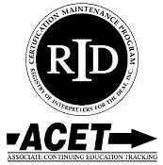
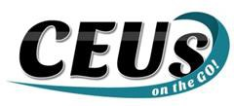

Should you require any accommodations, please contact Amy Lankheit at amy@bridgesfordeafandhh.org prior to October 2, 2020. This event upholds nondiscriminatory practices and encourages a learning environment of mutual respect and free from bias.

CEUs on the Go! is an Approved RID CMP Sponsor for Continuing Education Activities. This PS program is offered for 0.2 CEUs at the Some Content Knowledge Level.

