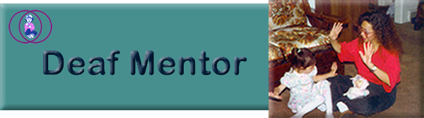
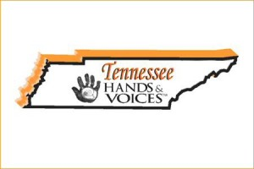TN Hands &Voices

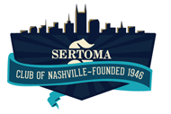SERTOMA Club of Nashville provided funding
to bring a National Trainer / Presenter to this conference.

An opportunity to learn about the
SKI*HI Deaf Mentor Program

At the

TN Statewide Workshop for Teachers, Parents, and Other Professionals
Serving Children who are Deaf or Hard of Hearing

Saturday, Nov. 5, 2016
12:30 – 2:45

Location:
TN School for the Blind
115 Stewarts Ferry Pike
Nashville, TN 37214

Registration Information:

http://www.tsdeaf.org/
look for link on home page

Deaf Mentor Program: Overview & History, Research & Benefits, Home Visit Scenes, Deaf Mentor in Action in the Home and Community, Simulation Experience, Implementation, Panel of Deaf Adults
Presenter: Jodee S.Crace, M.A., Indiana
Audience: Families with children D/HH DB, Deaf Adults, Professionals, and community members. Participants will stay with the Parent Track rather than alternate between afternoon options.
Program Description: The Deaf Mentor Program assists families and agencies in implementing bilingual/bicultural home-based programming for young children who are deaf. Children of hearing parents who receive the SKI-HI Model are typically exposed to an English-only approach (signed or spoken English) and to the hearing culture of their parents, family members, and parent advisor. The Deaf Mentor approach provides the family the choice of also using a Deaf Mentor (deaf adult) who makes regular visits to the home, interacts with the child using American Sign Language (ASL), shows family members how to use ASL, and helps the family understand and appreciate deafness and Deaf Culture. Meanwhile, the family continues to receive Parent-Infant Program services. This enables the child to learn both ASL and English and to be exposed to a bicultural environment of both "hearing" and "deaf" cultures.
For a more in-depth description: http://www.skihi.org/DeafMentor.html 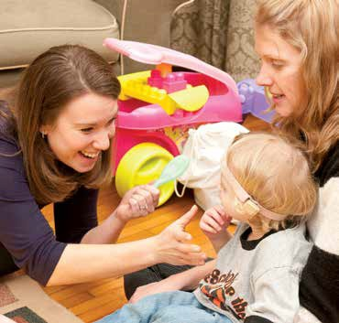
Scholarships available for families. Contact: kodi@tnhandsandvoices.org

