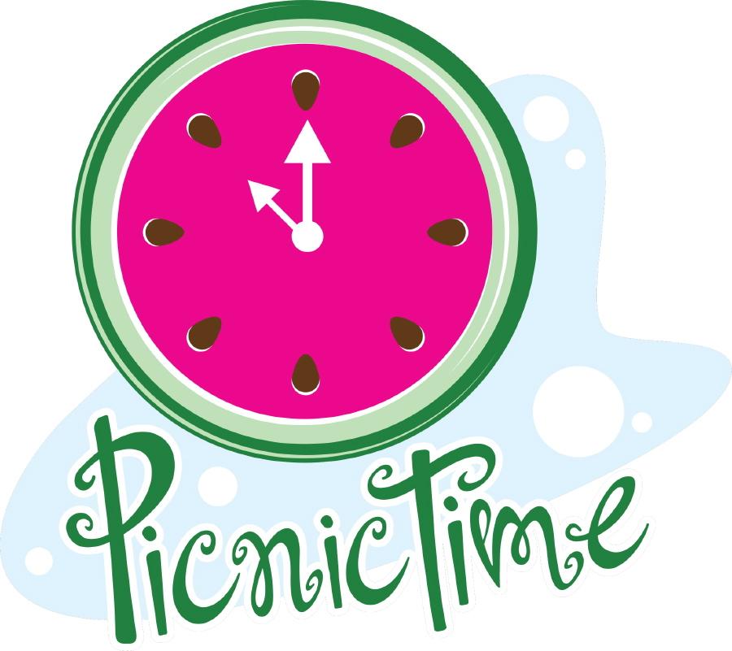

**FREE FREE FREE**

**FREE FREE**

# 

# COMMUNITY DEAF PICNIC

**WHEN:** AUGUST 9, 2014

**WHERE**: FANNIE MAE DEES PARK

2400 Blakemore Ave, Nashville, TN 37212

**SHELTER:** 1

**TIME:** 10 AM-?

WHAT: Provide Hot Dogs, Hamburgers & Drinks

Buy/Auction: Cakes, Cookies and Drinks

TO MEET OLD AND NEW FRIENDS AND WOULD LOVE FOR YOU TO MEET OUR NEW PASTOR ARIC AND HIS FAMILY

C:\Users\kjordan\AppData\Local\Microsoft\Windows\Temporary Internet Files\Content.IE5\99L98VDP\MC900054893[1].wmf