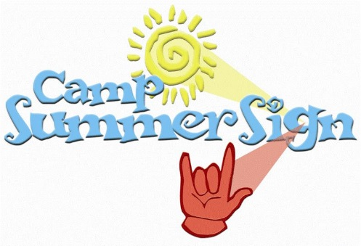
CampSummer Sign is an eight week day camp for deaf children and their siblings or CODAs.
Students between the ages of 6 and 14 are able to sign up to come to camp.
We take the students on field trips throughout the summer and have one big performance at the end of the summer for the parents to see their child preform.
The application is not available at the time and will be put on the library website when it is ready.
If you have any questions feel free to contact us by email or VP.
Email – smarshall@brentwoodbaptist.com
VP – (615) 290-5156

