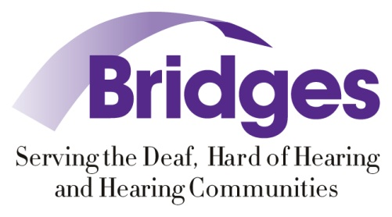
Bridges Presents:
CDI 101/102 &
WORKING TOGETHER
Friday, June 5, 9 a.m.-5 p.m.: CDI 101/102 for Deaf who want to become a Certified Deaf Interpreter. Education will be presented on the role of CDI and steps to become a Certified Deaf Interpreter.
Saturday, June 6, 9 a.m.-5 p.m.: Working Together for Deaf and hearing interpreters learning how to use each other in a teaming role to benefit the client. There will be special emphasis on mental health and legal situations.
For more information:
Go to http://bridgesfordeafandhh.org/event/interpreting_workshop
Or
Contact: Amy Lankheit (615) 248-8828 (voice)/(615) 290-5147 (VP) al@bridgesfordeafandhh.org
