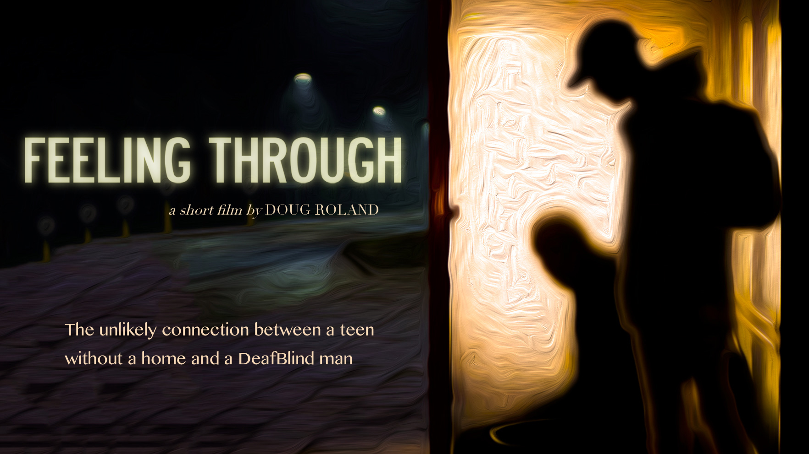 Movie Premiere

Sponsored by:

**www.ncdba.org**

**www.helenkeller.org/hknc**





The KY & TN DeafBlind Interagency Partners:

Division of Vocational Rehabilitation Services

KY Deaf-Blind State Coordinator with OFB/OVR

Tennessee & Kentucky Deaf-Blind Projects

Bridges for the Deaf and Hard of Hearing

Helen Keller National Center

Movie premiere starring the first ever DeafBlind actor

**FREEN TO THE**   **When: Thursday, June 27, 2019 12 p.m. – 4 p.m.**

**Where: The Franklin Theatre 419 Main Street, Franklin, TN 37064**

<https://www.franklintheatre.com/>

Register below by June 20th:

<https://www.eventbrite.com/e/deafblind-movie-premiere-feeling-through-tickets-61163469584>

Questions about the movie: [Marilyn.Trader@hknc.org](mailto:Marilyn.Trader@hknc.org)

HKNC Helps Make Film History with *Feeling Through*

What is it?

• For the first time ever: a DeafBlind man as a lead in a film

• The story: a short film about the unlikely connection between a teen

without a home and a DeafBlind man

• A companion documentary about the filmmaking process

Who's making this possible?

• Doug Roland, writer/director

• Former HKNC student and current staff member Robert Tarango's acting debut

• HKNC, proud fiscal sponsor Instagram: @feelingthrough

• Twitter: @feelingthrough1

Where can I see it?

• There will be a nationwide screening series, which will include a panel discussion

featuring members of the DeafBlind community

For updates and screening information:

Website: FeelingThrough.com Facebook: @feelingthrough Instagram: @feelingthrough Twitter: @feelingthrough1