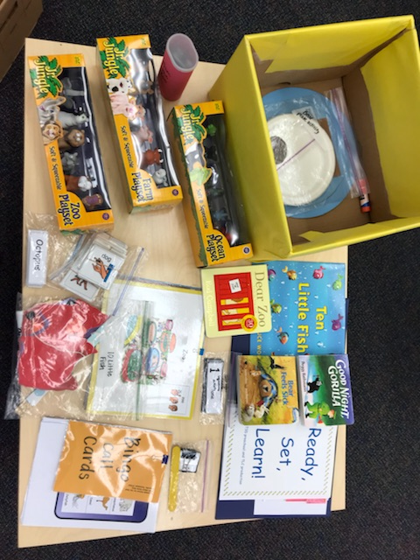  September 30  Ready, Set, Learn!  Families with Children with Hearing Concerns (18-36 months)  Join us and other families for a two-hour, hands-on workshop: “Animal Unit”.  You will also be able to talk with Teachers of the Deaf  about your specific concerns.  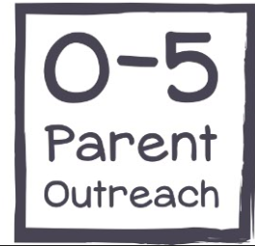  Register here:  https://www.surveymonkey.com/r/52YRYD8 | Literacy Activities for  ────  Parents, grandparents, or caregivers  ────  Learn how to use the Ready, Set, Learn! kit  ────  Encourage language development & literacy  ────  Take the box home!  Partnership Services for Family, Children, & Adults  5600 Brainerd Road, Suite E1  Chattanooga, TN 37411  Contact Alisa Weeks:  865-469-5592  September 30 3-5pm  Dates and Times
Comprehensive Educational Resource Center Tennessee Schools for the Deaf Jackson, Knoxville, Nashville

