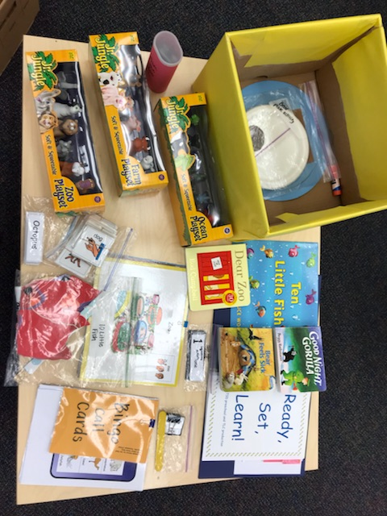  October 27  Ready, Set, Learn!  Families with Children (18-36 months)  with Hearing Concerns  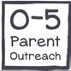  Join us and other families for a two-hour, hands-on workshop: “Animal Unit”.  Limited to 5 families. Please register by October 19, with the link below to reserve your spot.  https://www.surveymonkey.com/r/DJTPJGS | Literacy Activities for  ────  Parents, grandparents, or caregivers  ────  Learn how to use the  Ready, Set, Learn! kit  ────  Encourage language development & literacy  ────  Take the box home!  October 27  1:00 to 3:00  at DeafConnect of the MidSouth  144 N Bellevue Blvd, Memphis, TN 38104  Contact  Tracy Duncan 865-320-3754 or  Kristy Murdock  731-618-9106
Comprehensive Educational Resource Center Tennessee Schools for the Deaf Jackson, Knoxville, Nashville

