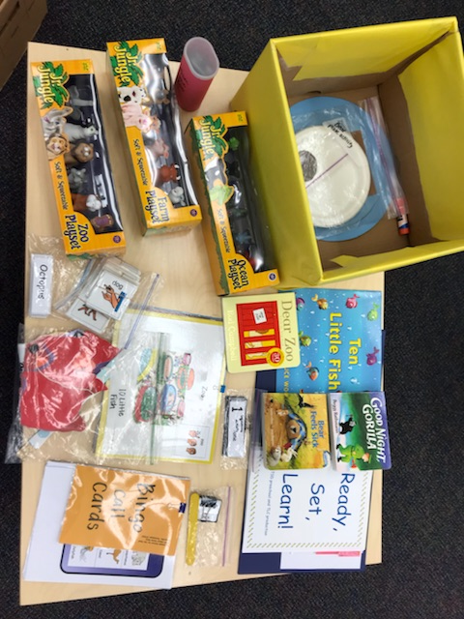  Thursday, October 25  Ready, Set, Learn!  Families with Children with Hearing Concerns (18-36 months)  Join us and other families for a two-hour, hands-on workshop: Animal Unit. You will also be able to talk with Teachers of the Deaf about your specific concerns.  Limited to Five / Register here before October 19th: https://www.surveymonkey.com/r/B9WRY8X | Literacy Activities for  ────  Parents, grandparents, or caregivers  ────  Learn how to use the RSL kit  ────  Encourage language development & literacy  ────  Take the box home!  23 Federal Drive  Jackson, TN 38305  Phone number: 731-664-3986 / (731) 668-2211  Directions: http://www.j-cil.com/deaf--hard-of-hearing-services.html  Thursday, 5:00 – 7:00 PM
Comprehensive Educational Resource Center Tennessee Schools for the Deaf Jackson, Knoxville, Nashville

