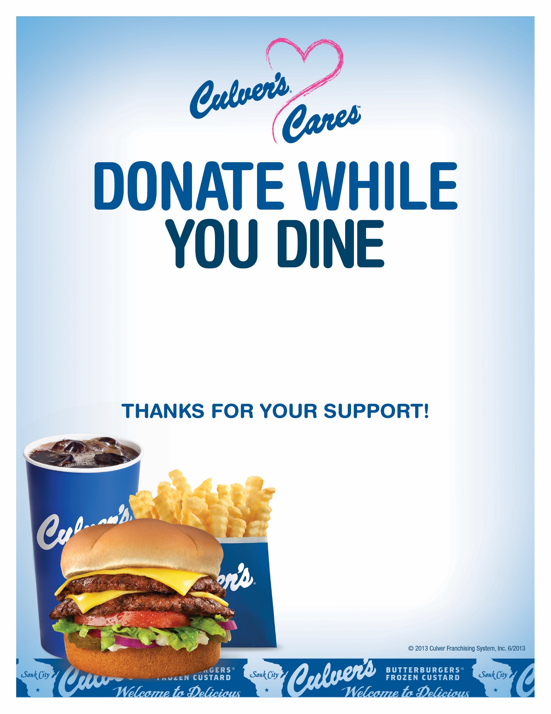

Visit Culver’s of HENDERSONVILLE on Oct 16 between 5-8pm and we will donate a percentage of all sales to SIGN CLUB CO.

Enjoy a delicious meal, benefit a great cause and feel good all over.

Come on in to your local Culver’s restaurant:

Culver’s of Hendersonville

290 Indian Lake Boulevard

Hendersonville, TN 37075  
615-265-8603