Presents

Learning from the experiences of our mentors
With TRID meeting
Tuesday May 30, 2017
6:15 PM meeting
6:30-7:30 PM Workshop
No charge to attend
CEU available 0.1 PS – free for TRID members
$5 for non-members if CEUs are desired
Tennessee School for the Deaf
2725 Island Home Blvd., Knoxville TN 37920 – Elementary School
Sign Language Interpreters and interpreting students will see with an overall picture of hurdles faced through previous decades, demonstrating what we can learn from the past by comparing changes that have occurred with areas still needing improvement.
Presenter Rose Byrum
Rose achieved her Associate of Applied Science with High Honors in Interpreter Training from McLenan Community College, Waco, Texas in 1984. She earned the following certifications:
Texas Society for the Deaf, General Interpreting Skills – 1981
Texas Commission for the Deaf, Level II – 1983
RID – Reverse Skills – 1980, Interpretation – 1981,
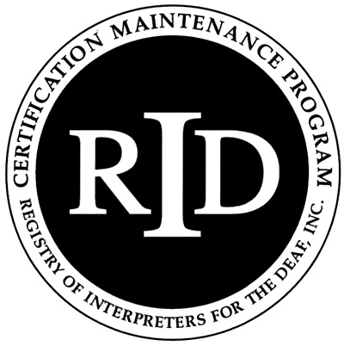
Transliteration – 1986
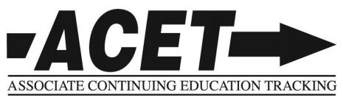
Rose has served as an educational and then a free-lance interpreter since 1970.

