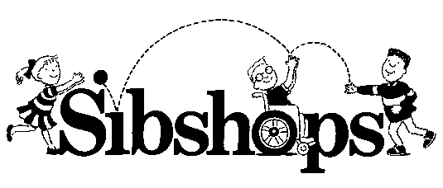

May 20, 2019

Dear Brothers, Sisters, and Parents:

We are happy to announce a SibShop event is available on Saturday, June 22nd, from 9:00 am -1:30pm. This is an option for your children to attend while you are at the Family Learning Day sponsored by the Tennessee Schools for the Deaf. Please read the enclosed / attached SibShop flyer.

Registration starts at 8:30 am. Children are in their programs at 9:00 am.

The SibShop will be at the same location as the Family Learning Day, the Tennessee School for the Blind. SibShop trained personnel from the TN School for the Blind, TN Deaf Blind Project, and Family Voices of TN will be hosting this event.

Sibshops are designed for brothers and sisters of children with special needs, between the ages of 8 -13, who are typically – developing.

The SibShop features a combination of activities, information, surprises, discussion, and lots of fun for everyone. You can pay the $5 registration fee on Saturday, when you arrive at the Sibshop, but phone registration is a must!! We need to know how much food to buy!

Call TONYA - let me know if you're planning to attend. Please RSVP!

615-905-6643

Wednesday, June 20th

Fill out the attached / enclosed registration form and bring it with you to the Sibshop...Hope to see all of you on Saturday, June 22nd!

Take care,
Tonya

Family Voices of TN  Tonya_b@tndisability.org | Victoria DeSalvatore (TN School for the Blind)  Victoria.DeSalvatore@tsbtigers.org | Danna Conn (TN DeafBlind Project)  Danna.conn@vumc.org

